Community engagement for EBRD stakeholders e-learning course
Practical guide for team leaders and managers

About this guide
This guide is for managers of community-facing teams. It helps to clarify the course features and enable you to allocate the appropriate time to completing the course. It includes information on timings, course content, interactive features and suggestions on how you might work on it as a team. The course was developed together with the community-facing teams of EBRD clients and reflects the realities that they face.

Purpose of the course
This course provides accessible and engaging material to train community-facing personnel (including those of contractors) and all project staff whose work relates in some way to community engagement and the insights gained from it (e.g., project managers).
We aim to encourage trainees to think differently about their own work and the context within which they work. Exercises and tests are aimed at critical thinking and problem-solving capabilities. Suggested team exercises are a key feature of the course: bringing community-facing teams together for training is an important team-building opportunity for people who often work remotely.

Timings
It is difficult to estimate the time it will take an individual to complete the course. However, we do appreciate that it is important for managers to plan in advance and allocate time for learning. We therefore advise the following (Levels 1-3 described below):
- Each module takes around 60 minutes to complete Level One material (i.e., all the compulsory material in the four modules), depending on the individual, e.g., how fast they read.
- If the trainee wants to explore the downloads and links to other resources (Levels Two and Three), it will take longer.
- If your team wishes to work through the course together in a workshop, doing the team exercises as they go, then each module lends itself to a half-day workshop.

Technical guide for all course users
A technical guide for all course users is also available on the course landing page. It helps to clarify the course features and optimise the learning experience. We recommend that you go through the technical guide with your teams before they start the course. Further guidance can be found in the course itself, where all steps are explained clearly.

Course content
To provide diversity in the learning experience, we have provided a range of different types of material throughout the course (see Table 1 below). The content can also be used in different training modes: face-to-face, hybrid, ‘tutored’ and self-directed experiences. Course participants can choose to access the course from a computer or a smart phone.
Table 1 summarises the different types of content. All the downloadable material is available in the Resource Library (see: Technical guide for all course users).

Table 1: Course content
Level | Description
Case studies | There are 6 downloadable case studies
Practitioner perspectives | There are 4 downloadable practitioner perspectives.
Guidance notes, templates, checklists and other tools | There are 21 downloadable guidance notes, templates, checklists and other tools.
Individual exercises | There are 12 individual exercises, including 7 exercises using ‘drag and drop’ and 5 exercises using a free text box
Team activities | There are 4 team activities
Video/animation | There is one animation and 2 videos.
Assessment | There is one assessment at the end of the course, with ten questions. The assessment answers are available to download after the assessment has been completed.

Flexible design: ‘four modules and three levels’ explained
The course has been specifically designed to be flexible and responsive to the needs of users with different priorities and capabilities.
- The course is made up of four modules, ALL of which need to be completed by ALL USERS.
- The flexibility is provided by the three levels at which we present the material (Table 1).
Users do not have to stick to one level. For instance, you could advise entry-level community-facing staff not to download any tools or materials as they go through the course. But they could still download something that is of interest to them, if they wish. They can also repeat the course later, when they have more experience, and download the additional material at that point.
As the team manager, you can download materials yourself and use them to design a bespoke training session to suit the needs of your own teams.
Table 2 below describes the different levels and their target users.

Table 2: Course levels
Level | Description | Target users
Level One: Engagement Essentials | - This is the basic material that ALL USERS need to be familiar with.  - Going through the entire course without downloading the optional materials will take the user through Level One.  - To get from one page to the next they will need to click on all interactive features that require a click (see Table 2 below) | - Entry-level community-facing personnel  - Senior project managers with limited time availability
Level Two: Practitioner | - This is additional material for practitioners who want to explore issues in more detail. They can download and read the material as they work through the course, or store it to read later.  - We have provided downloadable materials and tools, in the form of case studies, guidance notes and templates. | - Experienced community-facing teams  - Experienced social performance staff  - Team leaders and trainers
Level Three: Specialist | - Many of the downloadable materials and tools have links to further resources embedded within them. Users can also explore these if they wish to dive deeply into a particular issue, or view original guidance documents.  - Most of these further resources are in English only. | - As above, with knowledge of English language

Team activities are all Level One. In this course, the team activities are clearly signposted and are optional, but highly recommended if members of a team are taking the course at the same time. Team activities are an inspiring and invigorating learning method, and community liaison personnel benefit greatly from engaging with others who have similar community-facing roles. This material is suitable for mixed groups of new and experienced staff. All team exercises are designed to encourage participation from the wider project team, including, for instance, the community-facing personnel working for contractors.

Navigating through the course: the interactive “click” features
The course includes several interactive elements, which require the user to click on a particular feature. These are either compulsory (Table 2) or optional (Table 3).
All users need to click on all the compulsory features in order to get to the next page; they will not be able to access the next page without clicking on these features. The aim of this functionality is to modify the pace at which trainees read the material and to encourage them to interact with the material. The compulsory features include: tabs (with drop-down text); videos and animation; free-text boxes; picture icons; and ‘drag and drop’ exercises.

Table 2: Compulsory interactive “click” features
Feature | Description | Visual example
Tabs | If you click on a tab, a section of text drops down for you to read. You must click on all the tabs and read the content in order to progress through the course. | 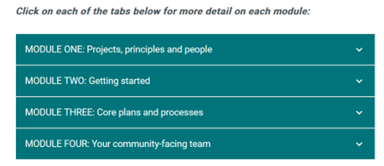
Video/ animation | All the videos and the animation are compulsory. You need to click on the ‘play’ icon.
Free text boxes | With free text boxes you are required to type in a response to the question written above it. When you click on ‘submit’ there will be a response with further information or guidance. | 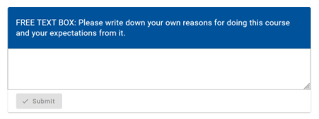
Picture icons | Text will be revealed if you click on the round icons that are displayed with pictures or graphics. The round icons contain a question mark, a cross or a location symbol. | 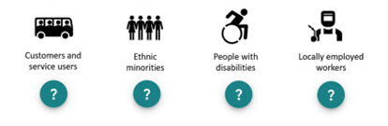
Drag and drop | This feature is used for the True/False exercises. You must click on a statement and drag it into the appropriate box. | 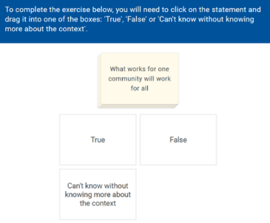

Three of the interactive features are optional.

Table 3: Optional interactive “click” features
Feature | Description | Visual example
Download boxes | To download a resource or guidance note, click on the cloud icon in the download box | 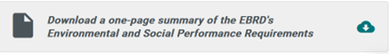
Glossary | Individual words in the glossary can be read by clicking on the words that are underlined, which reveals a pop-up box with the glossary definition.
 |  | 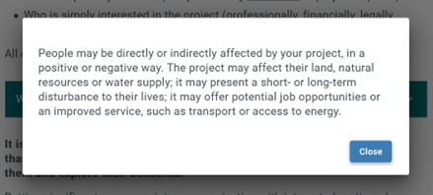
Direct web links | A few web links take you directly to an external site. These are indicated by underlined text with a square-and-arrow icon. N.B. The links take users away from the course pages.

Completing the assessment
An assessment is provided at the end of the course. The aim is to test trainees’ understanding of the key concepts and their ability to think through problems. The trainees must answer ten multiple-choice questions. Some of the questions have only one answer; others have more than one answer.
The trainee needs to get at least 80% correct in order to pass the assessment. They are allowed up to 5 attempts. A certificate is automatically sent to the trainee when they achieve the 80% pass mark. The certificate can also be accessed on their ‘My courses’ page.

Supporting your teams
Managers should support their teams as much as possible, by planning time thoughtfully in advance, ensuring that everyone understands what they should be doing, providing encouragement, and eliciting feedback throughout the process.
Here are a few particular pieces of advice:
- It is a good idea to set aside time and to have whole teams working on the course at the same time; but you need to enable them to fit it in with busy schedules
- Please do encourage users to do the course at their own pace, and encourage them to explore areas of particular interest to them. If they feel they need more time, discuss this with them.
- Encourage individual and collective feedback on each Module after they have completed it.
- It is a good idea to ask trainees to record separately what they write in the free text boxes and then discuss these comments with them individually or as a group.
- We encourage you to fit in team exercises between the individual learning sessions that your team carry out.
- Within the course material we encourage trainees to have breaks between modules. You should make sure that they take these breaks. If you think it is appropriate, you could encourage informal group discussion during the breaks.
- We place a great deal of emphasis on the topic of safeguarding. You may want to arrange a targeted group session to discuss that issue, and ask your team to share any concerns or suggested solutions themselves, in a group or as individuals.

We strongly advise managers and team leaders to take the time to do the course themselves!

If you have any comments or reflections on the material, how useful it is and how it relates to your own experience, please contact us at: ebrdcourse@audire.uk
The course is hosted on the EBRD’s e-learning platform, which is managed by EASST. Technical questions can be addressed to: d.sambuk@easst.co.uk

